Accounting Treatment of Accumulated Profits and Losses

i) For distributing accumulated profits and reserves

Profit and Loss A/c |  | Dr.
General Reserve A/c |  | Dr.
Reserve Fund A/c |  | Dr.
Workmen’s Compensation Fund A/c |  | Dr.
Contingency Reserve A/c |  | Dr.  INVESTMENT FLUCTUATION A/C DR.
 | To Old Partners’ Capital A/c
(Undistributed profits and reserves are distributed among old partners in their old profit sharing ratio)

ii) For distributing accumulated losses

 | Old Partners’ Capital A/c |  |  |  | Dr.
 |  | To Profit and Loss (Debit balance) A/c
 |  | To Deferred Advertisement Expenses A/c
 |  | To Preliminary Expenses A/c
(Undistributed losses are distributed among old partners in their old profit sharing ratio)

A and B are partners sharing profits and losses in
the ratio of 3:1. On Ist Jan. 2017 they admitted C as a new partner for 1/4 share in the profits of the firm. C brings Rs 20,000 as for his 1/4 share in the profits of the firm. The capitals of A and B after all adjustments in respect of goodwill, revaluation of assets and liabilities, etc. has been worked out at Rs 50,000 for A and Rs 12,000 for B. It is agreed that partner’s capitals will be according to new profit sharing ratio. Calculate the new capitals of A and B and pass the necessary journal entries assuming that A and B brought in or withdrew the necessary cash as the case may be for making their capitals in proportion to their profit sharing ratio?

Date |  |  | Particulars |  |  |  |  | L.F. | Amount  Rs | Amount  Rs
2017
Jan. 01 |  |  | A’s Capital A/c |  |  |  | Dr. |  | 5,000
 |  |  |  | To Cash A/c |  |  |  |  |  | 5,000
 |  |  | (Excess capital withdrawn by A)
 |  |  | Cash A/c |  |  |  | Dr. |  | 3,000
 |  |  |  | To B’s Capital A/c |  |  |  |  |  | 3,000
 |  |  | (Capital brought in by B to make in proportion to the profit sharing)
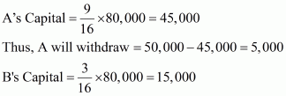

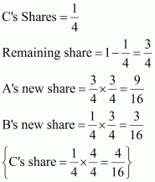
New Profit sharing ratio of A, B and C will be 9:3:4
2) New Capital of A and B.
C bring Rs 20,000 for 1/4th share of profit in the new firm.
Thus, total capital of firm on the basis of C’s share= 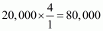
32.Pinky, Qumar and Roopa partners in a firm sharing profits and losses in the ratio of 3:2:1. S is admitted as a new partner for 1/4 share in the profits of the firm, whichs he gets 1/8 from Pinky, and 1/16 each from Qmar and Roopa. The total capital of the new firm after Seema’s admission will be Rs. 2,40,000.Seema is required to bring in cash equal to 1/4 of the total capital of the new firm. The capitals of the old partners also have to be adjusted in proportion of their profit sharing ratio. The capitals of Pinky, Qumar and Roopa after all adjustments in respect of goodwill and revaluation of assets and liabilities have been made are Pinky Rs. 80,000, Qumar Rs. 30,000 and Roopa Rs. 20,000. Calculate the capitals of all the partners and record the necessary journal entries for doing adjustments in respect of capitals according to the agreement between the partners?
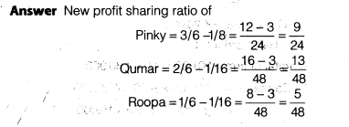
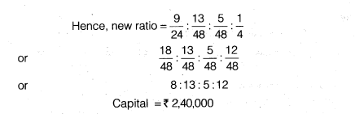
2) Required capital of all partners in the new firm
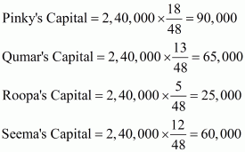
3) Amount to be brought by each partner
Pinky = 90,000 − 80,000 = 10,000
Qumar = 65,000 − 30,000 = 35,000
Roopa = 25,000 − 20,000 = 5,000
Seema = 2,40,000 =60,000
Books of Pinky, Qumar, Roopa and Seema
Journal

Date | Particularss |  |  | L.F. | Amount  Rs | Amount  Rs
 | Bank A/c |  | Dr. |  | 60,000
 |  | To Seema Capital A/c |  |  |  | 60,000
 | (Seema bring her share of Capital for 1/4 th share of profit)
 | Bank A/c |  | Dr. |  | 50,000
 |  | To Pinky’s Capital A/c |  |  |  | 10,000
 |  | To Qumar’s Capital A/c |  |  |  | 35,000
 |  | To Roopa’s Capital A/c |  |  |  | 5,000
(Amount brought by Pinky, Qumar and Roopa to make capital
equal to their proportion)

